For building a regression model to predict the price of a house in California, I have followed the next steps.
- Cleaning and Normalizing Dataset
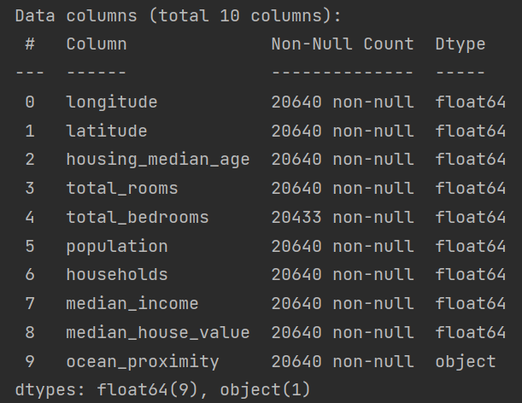

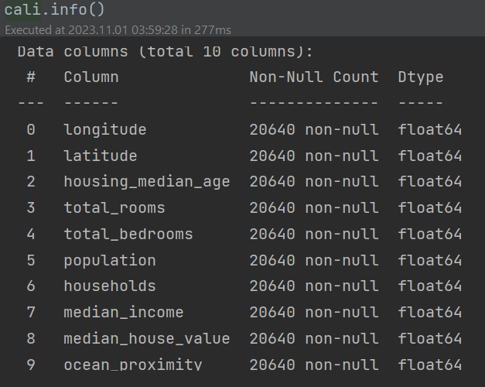
  - OrdinalEncoder has been used for normalization of ‘ocean_proximity’ feature
  - For NaN values has been used median mode for fillna method

- Looking for corelation
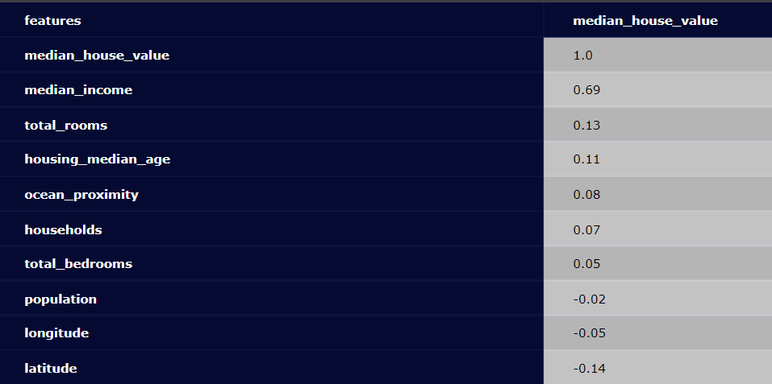
Observations:
  - median income seems to be an important factor with a correlation of about 0.7
  - next biggest but small correlation of about 0.1/-0.1 with the rest features
  - I think the lower negative latitude correlation can be explained with that lower latitude values indicate more closeness to the coast, and the coast tends to have higher housing prices.

- normalize the target distribution
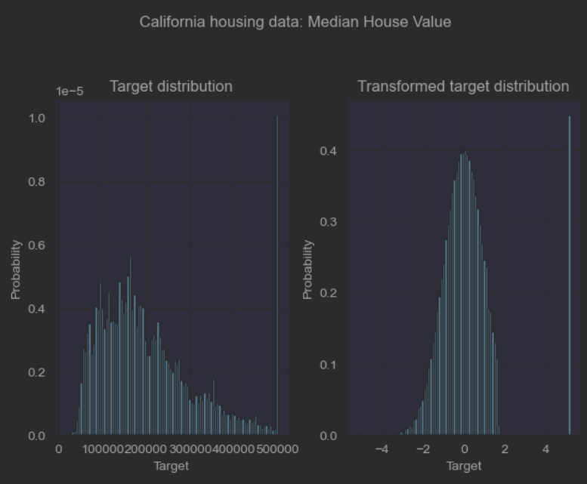

  - QuantileTransformer is used to normalize the target distribution before applying a RidgeCV (LinearRegression) model, the result was worst, not used in the model.

- Permutation feature importance

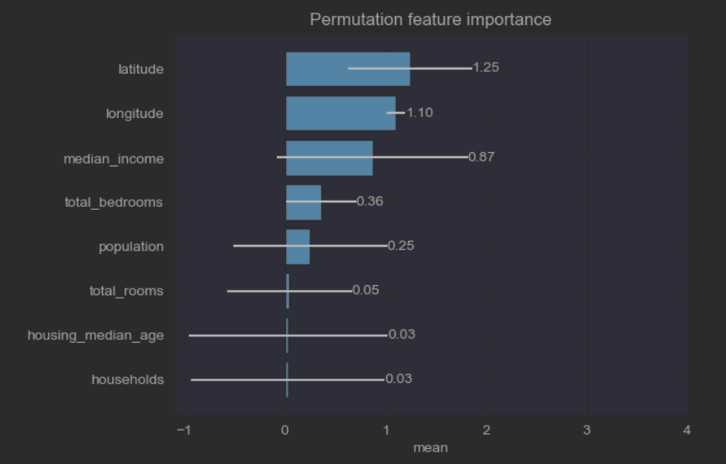

From the plot we can see latitude, longitude and median_income are of importance.

- Optimal Model Complexity
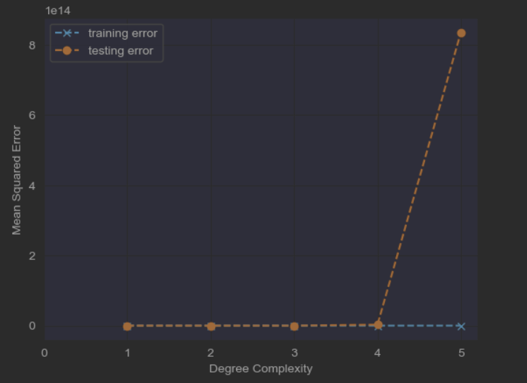

The best degree of complexity is 2, which is not very clear from the above plot

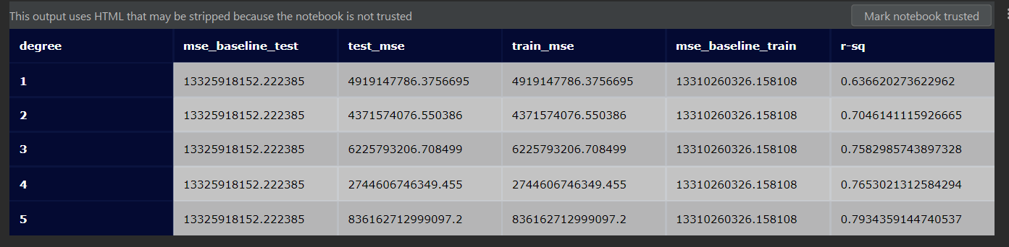

  - The model has been trained with five sequential Polynomial degrees, looking at the mean-square-error(test_mse) the smallest test error is for degree 2. So we will will build a quad Polynomial model

- Quad Polynomial Model
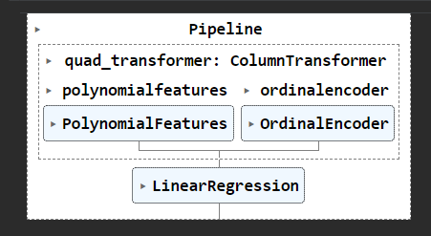

- Conclusion
  - The model performed better comparing test_mse = 4.371574e+09 against the mse_baseline_test = 1.332592e+10, also the training set has better characteristics against the baseline training set; train_mse=4.371574e+09 and mase_baseline_train=1.331026e+10.
  - The R-sq is 0.704614, which indicates that the regression predictions perfectly fit the data.
  - Train/Test split is test_size=0.33, random_state=42

- Plots of Predict, Model and Actual House Prices
  - Actual
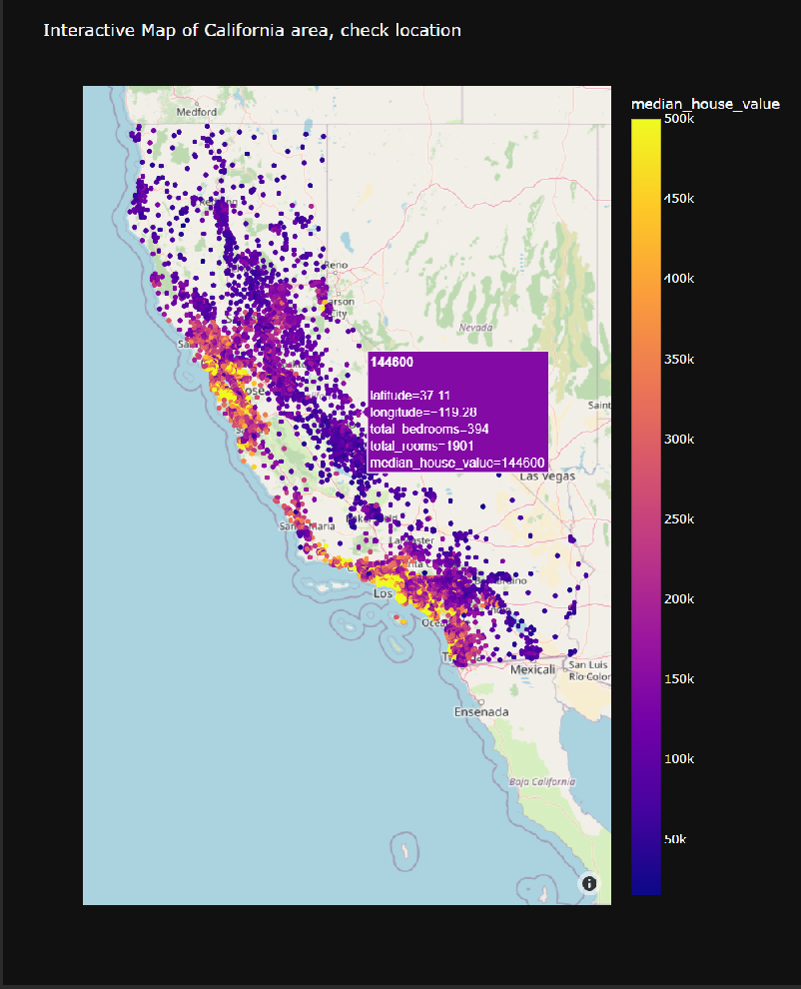

  - Predict

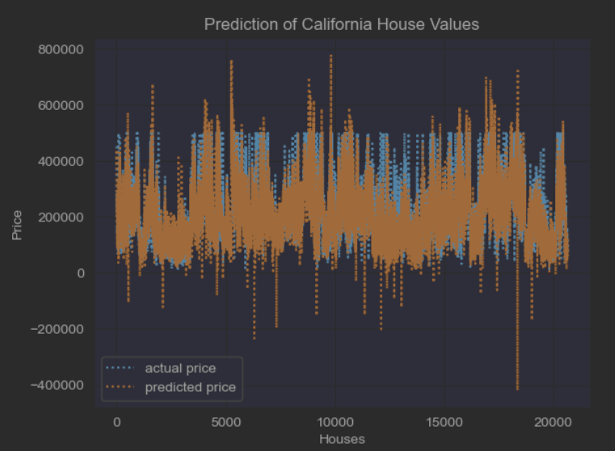
From the above plot we can see the actual house value are capped, also nice a prediction for house values, probably influenced by the permutation features importance as latitude, longilude and median_income.
We see plenty outliers, it will be nice for which area the model predicts that negative house price, it needs further investigation.

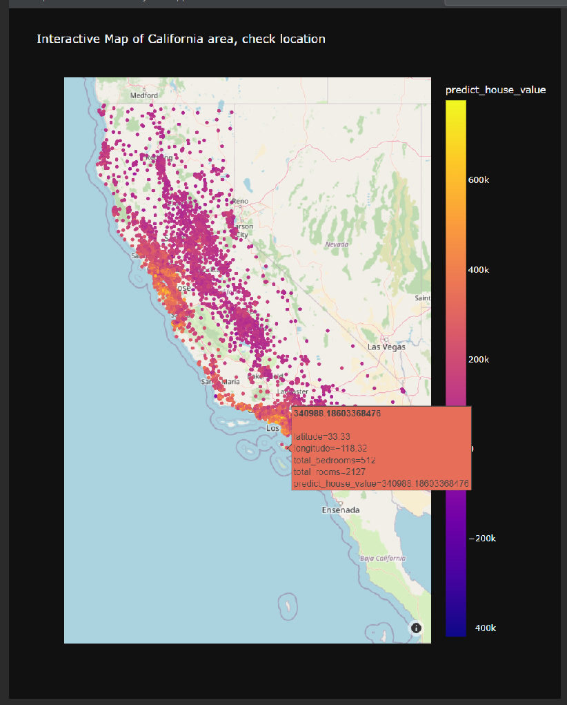

  - Model
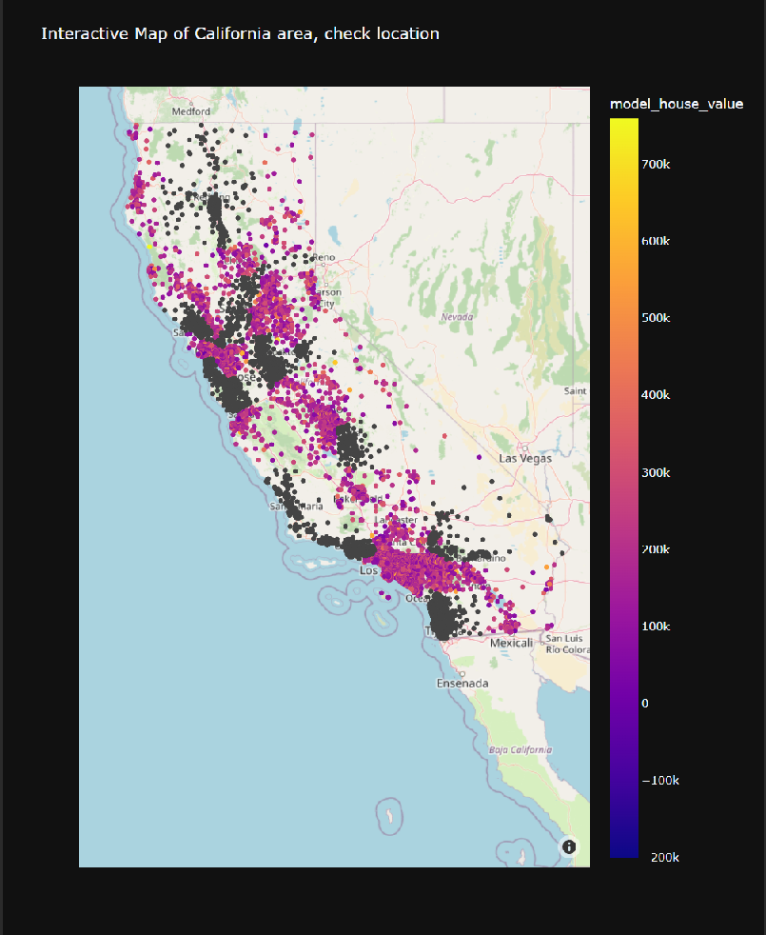

As the the data set is split on train and test sets, the abobe plot explains at 67% of data, so we can see which area have not been covered by the model.

